Grantham Sprint Triathlon 2018

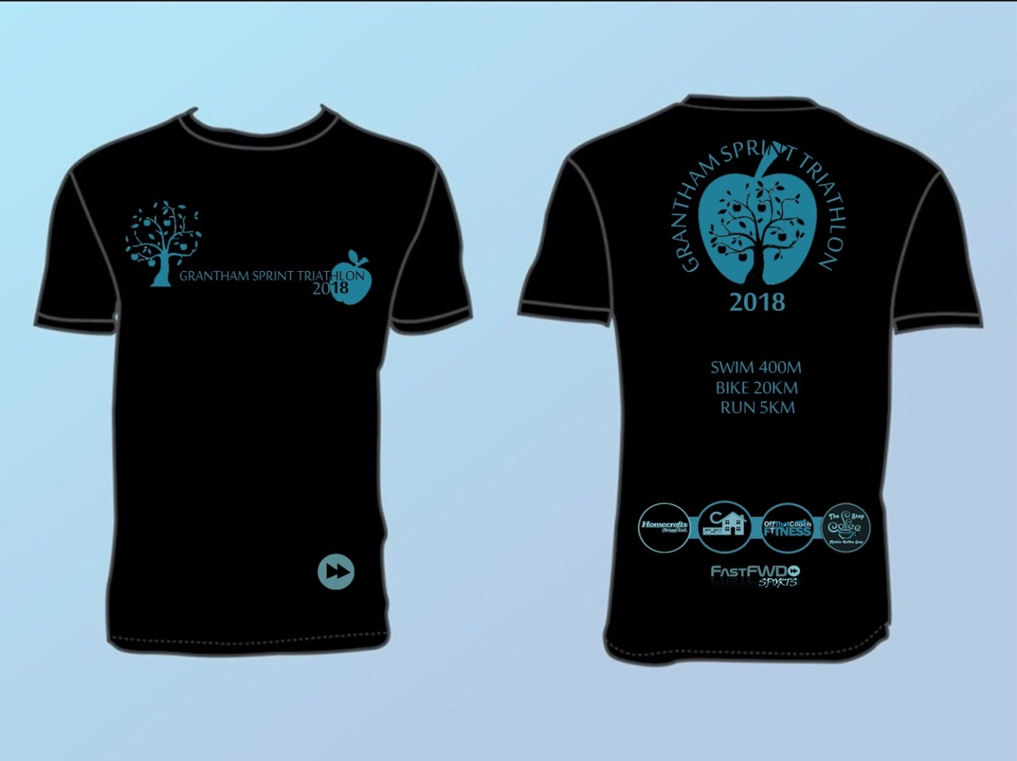

Sunday 13th May 2018

Grantham Sprint Triathlon 2018
Race Information Pack
PLEASE TAKE THE TIME TO READ

Event Details

Grantham Sprint Triathlon 2018

It is a fast, flat course, ideal for novices and experienced racers alike. The distances are 400m Swim, 18km Cycle and a 5km Run.
Venue:
Meres Leisure Centre
Trent Road
Grantham
NG31 7XQ
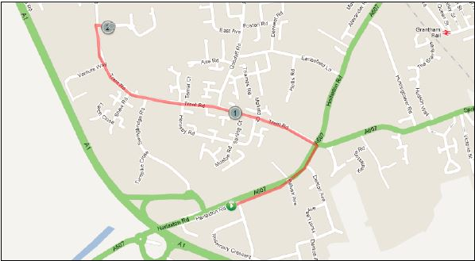
Race Start Time:
Wave 1 off at 9:00am

Race Registration:
Saturday 10th May 5.00pm – 7.00 pm (near Transition Area)
Sunday 11th May 6:00am – 7:30am (near Transition Area)

Adults Race Briefing:
8:00am (Transition Area) All competitors to attend.

Safety
The first and most important consideration is the safety of all competitors and volunteers.
We have completed Risk Assessments and do our best to highlight any hazards etc.
You as a competitor have a Duty of Care to yourself and others. You must also be sure of your abilities and fitness to compete in, and complete the 3 disciplines. You MUST have regard for other competitors and officials, all of whom give their time for your pleasure and pain! Please take time to carefully study the pre-race information to ensure you have a smooth and enjoyable day out. The race starts at 9am and will be on set off in waves of five. Individual start times will be emailed prior to the race and also on display on the day at registration. Minimum age is 16 years.
Venue
Mere’s Leisure Centre,
Trent Road,
Grantham,
NG31 7 XQ.
Situated south west of Grantham centre, close to the A1, From A1 take A607 junction into Grantham, then turn left onto Trent Road, and turn right into Leisure Centre. Ample Car Parking is available.
Registration
Race registration will be open on Saturday & Sunday (times stated above) and is located close to transition (see map).
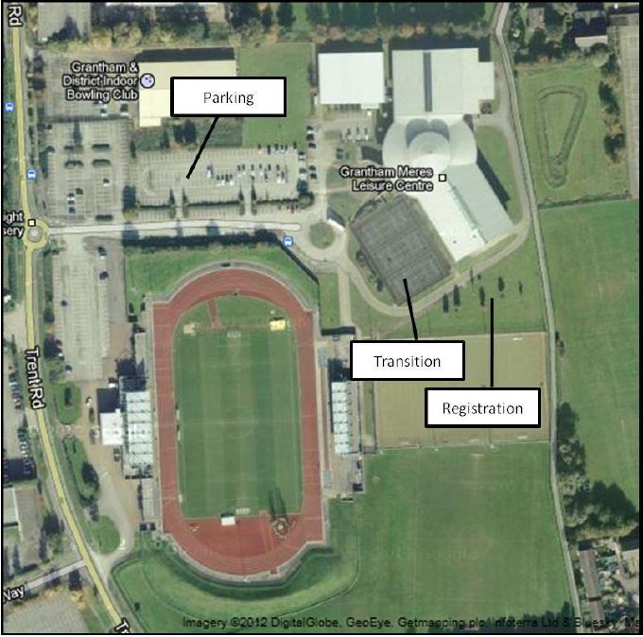
You will be issued with two race numbers for front & back of your race top, if you are wearing a race belt the number must be visible on the rear for the bike section and on your front for the run section). There will also be a sticky number your bike. You will also be issued (if not a BTF member) a BTF day license & a timing chip to place on your LEFT ankle. To ensure the security of the timing chip it is advised that you secure the Velcro strap with the safety pin(s) provided.
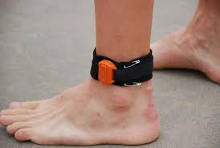
All competitors will receive a goody bag at registration.
Transition Area (opens at 6.00 am)
The Transition Area for the cycle is located close to registration in the tennis courts of the Leisure Centre (see map). Please ensure that the numbered sticker (1 provided) is clearly displayed on your cycle and you are correctly wearing (fastened) an approved (ansi/snell) cycle helmet, before entering the transition area.
The cycle racking is numbered and we ask competitors to rack to their assigned number accordingly. Please approach your numbered position with the number facing you and after racking your bike place your transition gear near the front wheel of your bike, please remember to keep your transition area tidy as space is limited. Cycles and your gear can only be removed after the race by showing your race number. Can all competitors ensure that their cycles are racked before 7:45am.
Only Competitors allowed in the transition area!
Changing Facilities
Changing areas and showers are available within the Leisure Centre.
Race Briefing
All competitors must attend.
There will be a short pre-race briefing at 0800hrs in the transition area.
Swim (400m)
The event will start at 9am please enter the swim area via the normal pool entrance in the Leisure Centre at least 10 minutes prior to your start time. The pool is 8 lanes & 25 metres in length, start times will be staggered (dependant on your estimated swim time) at 2 minute intervals. Please ensure you check in with the pool marshall 10 minutes before your start time (start times will be published in the week before the event). You will be asked to enter the water 30 seconds before your start time & given a countdown, you will swim 16 lengths, on completion of your swim you must exit the pool via the doors indicated, please DO NOT run while still on the edge of the pool as this is slippy. Once outside the leisure centre follow the route out of the doors, across the delivery road and into transition through the swim/ bike IN gate.
Please remember it is your responsibility to count your 16 lengths, marshals will be conducting spot checks, anyone found not completing 16 lengths will either be disqualified or subject to a time penalty.
Please remember that you will not be in a lane by yourself, if a faster swimmer taps your toes please let them through at the end of the next length. Faster swimmers may also over take down the middle of the lane but please take care of oncoming swimmers.
All start times and lane numbers will be advised approximately 1 week prior to race day via email.

Cycle (18km) 2 laps
In transition ensure that you put your helmet on and fasten the strap before touching your cycle. Collect your bike and leave the transition area via the OUT gate pushing your bike until you reach the designated area to mount your cycle on the delivery road.. Follow the road to the leisure centre exit where it meets the main road taking care of any traffic. PLEASE ENSURE THAT YOU CHECK FOR TRAFFIC APPROACHING FROM YOUR LEFT & RIGHT before joining the main road at the roundabout and turning right to join the bike course.
Continue to the end of Trent Road, then turn left (taking care of traffic approaching from the right) onto Dysart Road. The route turns left just before Barrowby following The Drift towards Harlaxton, turning left onto the A607 Grantham Road, follow the route signs to bring you back onto Trent Road and towards the Leisure Centre, where you will pass the leisure centre and repeat the loop a second time. On completing your 2nd lap, turn right into the Leisure Centre carefully watching for traffic and other competitors, and follow the road back towards transition, dismount where indicated and enter transition through the swim/ bike IN gate.
DO NOT REMOVE YOUR HELMET (OR UNSTRAP YOUR HELMET) UNTIL YOUR BIKE IS RACKED SECURELY.
Rack your bike at your previous numbered position and have respect for your fellow competitor.
You must always abide by the HIGHWAY CODE and please remember that marshals are not permitted to stop any traffic, you alone are responsible for your own road safety!
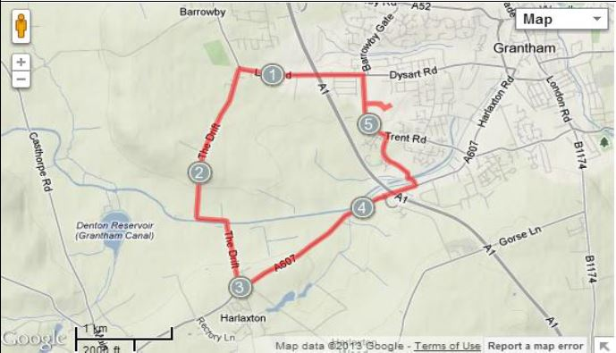
No Drafting Rule
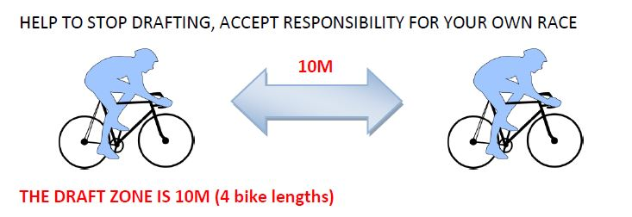
What happens if I want to pass a competitor in front?
- You have 30 seconds to enter the draft zone and to overtake
- If you have not passed within 30 seconds YOU must drop back to outside the draft zone

What happens if another competitor passes me?
- YOU must drop back to outside the draft zone

Can I ride side by side with another competitor?
- NO unless the roads are closed

Only one person can be first over the line, but everyone can win by holding their head up and saying they were not guilty of drafting. Penalties will be imposed on competitors breaking these rules.

Run (5km) 2 & half laps
Exit the transition area through the OUT gate, and through the opened fence, turning right onto the pathway (the green arrow on the map).
Proceed to the end of the pathway turning right as you rejoin Trent Road, here you will collect a band. Proceed along Trent Road towards the Leisure Centre, continue across the Leisure Centre entrance (you have completed half a lap), taking care of traffic & other competitors. At the end of Trent Road turn right onto Dysart Road (staying on the pathway) then take your next right. At the end of the cul-de-sac take the pathway behind the leisure centre to rejoin the run route. Again you will collect your second band as you re-join Trent Road. As you approach the Leisure Centre entrance again, taking care of traffic & other competitors cross the road and continue to the end of Trent Road, turning right onto Dysart and right again into the cul-de-sac and pathway behind the Leisure Centre. When you rejoin Trent Road you will collect your 3rd and final band. When you approach the Leisure Centre entrance this time, turn right following the pathway to the finish line near transition.
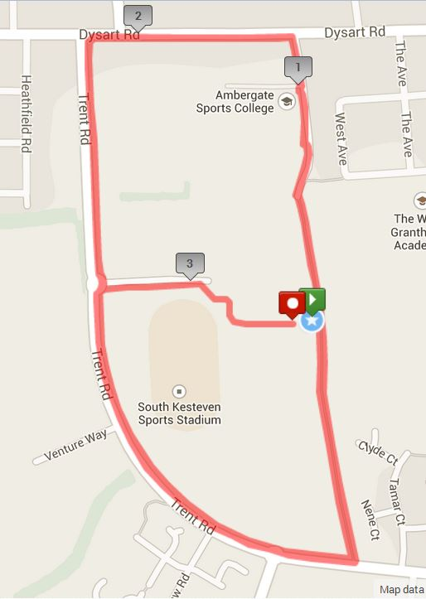

Prizes and presentation

Presentation will be held at the registration area shortly after the final competitor has finished. There will be awards for 1st, 2nd & 3rd in male & female categories, and also every age group winner male & female (age groups 20-29, 30-39, 40-49 and 50+)

Results
Results will be available online the same evening of the event at www.FastFWDSports.co.uk

Contact
If you have any issues before race day please email Info@FastFWDSports.co.uk, and on race day please see the Race Director David Hinch or Senior Marshalls Steve Clark and Andy Veitch.

Please have safe and enjoyable race and help us to make this a regular event on the triathlon calendar.
Please show respect for all marshals as they are volunteers and without them it would not be possible for the event to take place, a simple thank you post race goes a long way.

BTF East Midlands Region Youth Race Series
We are pleased to announce this years Grantham race has been chosen as a round of the East Midlands BTF region Kids triathlon series. This will consist of an Aquathlon (swim/run) with distances based on the age of the athletes and will take place in the grounds of the Meres Leisure Centre.

Please note the Youth races will be started PRIOR TO the adult race and the changing rooms will be out of bounds to non competitors.

We hope you have a good day and wish you every success no matter what your goal.

