OXLEY GoTri
AQUATHLON
Sherborne
23rd September 2017
Race Manual
The Oxley Triathlon is supported by:

This Athlete Manual contains all the essential information for the events including race rules, so please read it carefully!

Welcome
Welcome to the 1st Oxley Aquathlon run by Wessex Wizards Triathlon Club (www.wessexwizards.co.uk).
Supported by and with many thanks to our hosts Oxley Sports Centre. Our thanks and gratitude also go to the marshals and officials, without whom the race could not take place.

Race HQ Facilities
Car Parking
There is free car parking available at Oxley Sports Centre car park from 06:00. See map below. The sports centre is clearly marked on Bradford Road. The post code is DT9 3QN.

Strictly no dogs allowed at the venue as it is a school sports field.

Race HQ & Information Point
The Race HQ and information point will be located in the Coffee Pod to the left of the main reception. You will need to register at race HQ on arrival before you change and place your running gear in the transition area.

Centre Facilities
Changing facilities, toilets and showers are available at the centre for your use. A £1 coin is needed for the lockers, which is returned after use.

We have been very fortunate to secure the use of this fantastic venue. Please help us work towards being invited back again by not dropping any litter.

If you have any friends, family or guests who wish to volunteer as marshals, please make us aware at registration.

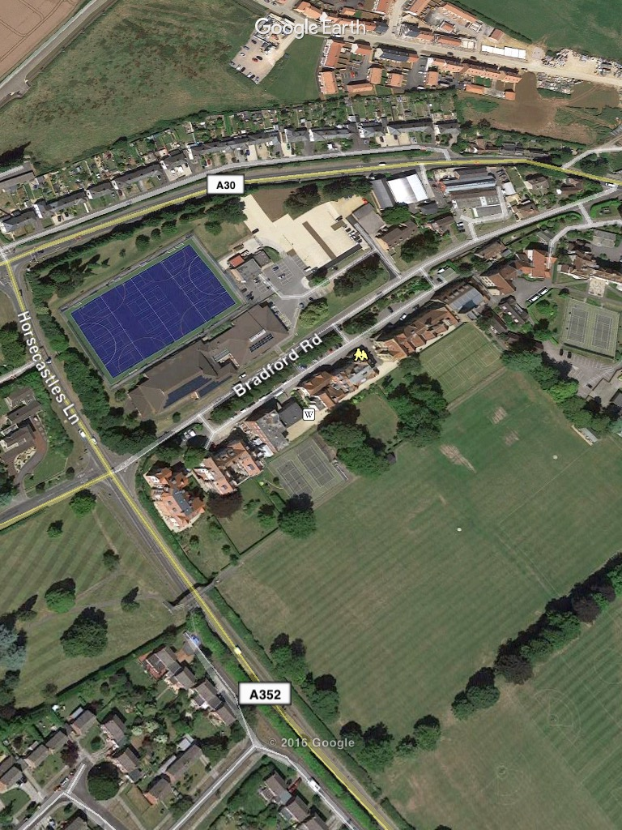
3
2
1
- Car Park 2. Registration 3. Transition

Transition Area
This is located outside of the fire escape from the pool.

This area is restricted to competitors only. You will only be allowed access with a race number written on your arm. Please ensure this is done before you approach the entry marshal.

Please try to keep the transition area free of unnecessary clutter. You will need your run shoes and any other additional items needed for the run.

Make sure you take some time to look at the entrances/exits and make a mental note of where your kit is placed!

Race Distance
Aquathlon: 300m swim & 3km run

Pre-race
Registration will take place in the Coffee Pod to the left of reception and is open from 08:15. No entries on the day will be available.

If you have stated that you are a British Triathlon member and you fail to show their BTF licence, you must purchase a day licence for £3 cash in order for you to be insured to race. This is standard across all British Triathlon events.

Competitors will be issued with:
Race Number body marking (please do not wash off)
Start time

The Swim
The swim will take place in the 25m pool with each child swimming up and down each length before crossing under the lane floats and repeating etc.

The lane marshal will tell the competitors which direction to swim in and tell them when they can enter the water.

Competitors will be set off at different times, with the slowest swimmer leading the lane and others following behind.

If they feel a swimmer behind them touch their feet they should let them pass at the end of the next length.

Transition
Once you have finished your swim, you will leave the pool area at the deep end through the double doors. No running at poolside. You MUST leave your running kit in the transition area. Exit transition through the right exit and safely cross the road and follow the race signs.

The Run
The run course is around the sports field and clearly marked out using ORANGE stakes and safety tape. It is your responsibility to complete the required number of laps (3).

Courses will be as accurate as can be within constraints of the sports filed.

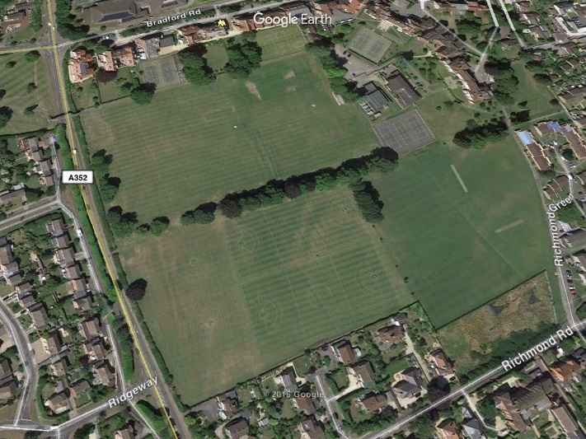
RUN x 3 laps
FINISH

Contacts
Emergency Race-Day Contact
Post Race Results
Results will be posted on the Wessex Wizards website (www.wessexwizards.co.uk) as soon as possible post race.

