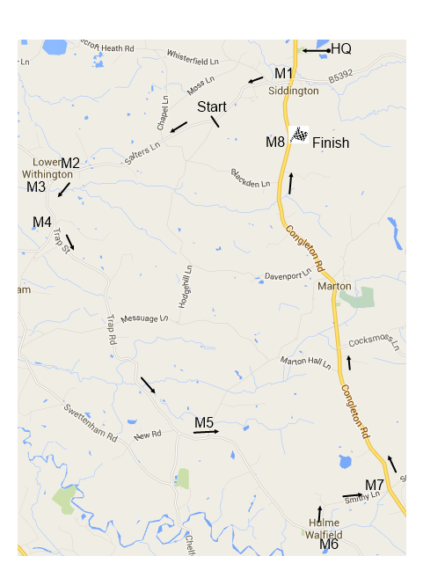  Race 3 First prize £60  E F G W  £50 £30 £30 £30  £30 £20 H  £20 £30  Max prize £60 any rider.  Race 2 First prize £60  C D  £50 £50  £40 £30  £30 £20  £20 £15  Race 1 First prize £60  A B  £50 £50  £30 £30  £20 £20  £15 £15  Please assemble outside the HQ in race groups behind the Lead Car for a rolling start. Proceed south on A34 to Siddington Crossroads. Turn right onto B5392 (M1). The race is neutralised to the start line just beyond Siddington boundary sign. Proceed to Lower Withington (M2). Left past the Red Lion Pub (M3) along Twemlow Road to the first left into Trap Street (M4) which eventually becomes Giantswood Lane. Left through Gleadsmoss (Black Swan Pub) continue through Newsbank (M5) to Hulme Walfield. Left into Smithy Lane (M6) Left onto A34 (M7). Continue through Marton and the Finish Area to Siddington crossroads (M8). Left onto B5392 and continue for the appropriate number of laps.  THE MARSHALS ON THIS RACE WILL NOT DIRECT TRAFFIC AT ANY POINT ON THE COURSE. YOU MUST LOOK TO YOUR OWN SAFETY AT ALL TIMES. OBEY THE HIGHWAY CODE. Helmets are compulsory. Please ensure that your numbers are clearly visible.  Licences will be collected. No Licence No Ride. Please Ride Safely Enjoy the Race | Steve Gutteridge Memorial Road Race  Sunday 5th May 2019 10am start  Promoted by Liverpool Century Road Club  Race organiser: Ian Watson  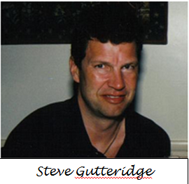  Race Headquarters: Siddington Village Hall, Congleton Road, Siddington, SK11 9JR  Parking: At village hall only; please do not park on the road or at the finish area.  Race Winners £60  Bikemarshals will provide 2 motorbike marshals on each race  Acknowledgements  Liverpool Century Road Club would like to thank Hazel Gutteridge and Peter Fawcett for their continuing generous financial support for this event.  The organiser wishes to thank Liverpool Century Road Club members, who provide the lead cars and marshals, thus making this race possible. There is ample parking space at the village hall. Please leave the hall and the grounds as you find them. This is the 17th edition of this race in Steve’s memory.  Thank you for taking part; please make this event memorable for all the right reasons. We had complaints from members of the public last year about riders throwing litter. Please refrain from throwing litter or leaving litter at the headquarters, as doing so so may affect the future of the event.

Race 1 A & B Start 10:00 52 miles
1 | Paul Allen | A | Pro Vision RT
2 | nick boden | A | Common Lane Occ.
3 | David Bratt | A | Pro vision
4 | Chris Edwards | A | Ludlow brewery RT
5 | Simon Frost | A | Congleton CC
6 | Paul Gibson | A | Surface Design
7 | Olly Humphreys | A | Geared up cycles
8 | john proudlove | A | 3C Payments
9 | ALED ROBERTS | A | Clwb Beicio Egni
10 | Simon Ward | A | Ludlow Brewery RC
11
12
13
14 | Simon Bridge | B | Manchester BC
15 | Martin Callaway | B | Cambridge Vets RT
16 | Christopher Davies | B | Ludlow brewery RT
17 | james dyson | B | 3RT
18 | Andrew Evans | B | Ludlow Brewaty RT
19 | fraser howard | B | Stourbridge Velo
20 | G McGuinness | B | Energy CC
21 | Ash Miles | B | Cc giro
22 | Christopher Quin | B | Onimpex Bioracer
23 | Martin Rigby | B | Moda RT
24 | Jeffrey Saycell | B | Ystwyth CC
25 | andrew sedgewick | B | Rutland CC
26 | Darren Shaw | B | Stourbridge velo
27 | Karl David Smith | B | Lancashire RC
28 | Chris Spencer | B | Onimpex Bioracer RT
29 | Stephen Talbot | B | pro vision
30 | ANDREW TURNER | B | ELEMENT CT
31 | Mark Wood | B | 3C Payment sports
32 | Tony Workman | B | Team Lusso
33
 | Race 2 C & D Start 10:05am 41.5 miles
35 | Stephen Blaney | C | Kuota gsg
36 | karl caton | C | Elmsall road club
37 | paul clare | C | Out of the Saddle
38 | David Curtis | C | Rutland CC
39 | Simon Degg | C | Stone wheelers cc
40 | Steve Degnan | C | Calder Clarion
Race 2 C & D Start 10:05am 41.5 miles
41 | Dean Drinkwater | C | CC London
42 | andrew dumbill | C | Lichfield ccc
43 | Mark Fenton | C | Pro Vision
44 | Lee Forrest | C | Solihull cc
45 | ian Foster | C | BC velo
46 | Jimmy Froggatt | C | SKCC
47 | Tony Grassby | C | Peak Road Club
48 | Chris Green | C | J's shack rc
49 | Andy Harrison | C | Harrison Digital Media
50 | Gerard Heap | C | Macclesfield Wh.
51 | Marc Hughes | C | Common Lane Occ
52 | P Kettleborough | C | Ilkley CC
53 | Ron Plumbley | C | L'pool Mercury CC
54 | Peter Reid | C | Manchester BC
55 | karl Smith | C | bott cycle team
56 | david thorpe | C | VC Monsal
57 | Paul Thursfield | C | Graham Weigh RT
58
59
60 | Stephen Baillie | D | Manchester BC
61 | Simon Bills | D | Provision RT
62 | Robert Blackburn | D | 8 point 8 group
63 | Melvin Blackford | D | Vive Le Velo
64 | Paul Brownbill | D | Port Sunlight Wh,
65 | Alan Crooks | D | Elmsall r c
66 | Steve Davies | D | Onimpex rt
67 | gary duncan | D | Oswestry paragon
68 | Andy Eagers | D | Derby Mercury
69 | martin harney | D | Manchester BC
70 | Simon Higgins | D | L'pool Century RC
71 | Roy Holmes | D | Bott Cycle Team
72 | David Kent | D | St Helens CRC
73 | Julie Mann | D | Transition RT
74 | Craig Maude | D | VSCC
75 | John Moore | D | MBC
76 | mark Mullender | D | cc giro
77 | Ian Noons | D | stone wheelers
78 | Sean Smith | D | Halifax Imperial Wh.
79 | A Tabernacle | D | Bott Cycle Team
80 | Martin Tolley | D | Stafford RC
Race 3 EFGW Start 10:10am 31 miles
81 | Stephen Booth | E | Audlem CC
82 | david broadbent | E | Kuota gsg
83 | Tony Carter | E | Independent
84 | Ian Cowan | E | Solihull CC
85 | chris danby | E | seamons cC
86 | Rob Finch | E | Arctic Tacx RT
87 | James Giblin | E | Manchester BC
88 | Nick Giles | E | Poco Loco R.T
89 | Ian Iveson | E | East Lancs
90 | Sally Maitland | E | Peak Road Club
91 | Paul Mason | E | Audlem CC
92 | john poole | E | Team Echelon-rotor
93 | Geoff Rawlinson | E | St. Helens crc
94 | Tony Rees | E | Ribble
95 | Dave Robinson | E | Manchester BC
96 | Geoff Saxon | E | ProVision RT
97 | Marcus Walker | E | Bush-Healthcare
98 | S Wilkinson | E | ELEMENT C.C.
99 | Len Best | F | Matlock CC
100 | Barry Beswick | F | Team Wheelguru
101 | stephen Bunn | F | welland valley cc
102 | John Buxton | F | LVRC
103 | Alistair Cameron | F | Chevincycles Trek
104 | Dave Cuming | F | Graham Weigh RT
105 | john duckett | F | bath cc
106 | Malcolm Fraser | F | Lusso Racing Team
107 | David Higham | F | Macclesfield Wh.
108 | Peter Hudson | F | Paramount CRT
109 | Andy Jones | F | Wolverhampton Wh
110 | Terry Meechan | F | Ride Coventry
111 | Malcolm Moore | F | Team Jewson
112 | Brian Pearson | F | Lakes RC
113 | Joe Rowe | F | Bush Healthcare CRT
114 | Dave Scargill | F | Birdwell Whs
115 | Mike Allen | G | MI Racing
116 | Bill Cotton | G | Belper BC
117 | gordon walters | G | bush healthcare crt
118 | John Ginley | H | Shibden CC
119 | sarah cramoysan | W | PTR

